Title – Times New Roman 16 points bold
Author1* – Times New Roman 12 points†, Author2‡
† Affiliation1 – Times New Roman 10 points italics
‡ Affiliation2
*corresponding author: include the author’s email address

Extended Abstract – Times New Roman 14 points bold
Extended abstract text – should be three (3) pages maximum – Times New Roman 12 points including any illustrations, figures and tables if necessary. Page should be A4 with 2.5 cm margins with header at 0.75 cm. Proofing language recommended is British English. In this extended abstract, the authors should try to present their case, their innovative idea or application and provide critical information, a case study, evaluation results and comparative studies where appropriate to support their case. Authors are expected to support their claims in the abstract text using appropriate evidence, facts and quantitative or qualitative evaluation (even at a preliminary form). A limited number of figures and tables should be included in the text as centred figures/tables with accompanying captions as shown in the example below.
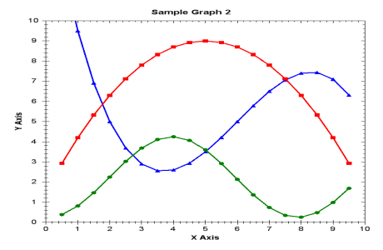
Fig.1. This is a caption example (10 points Times New Roman centred)

Table I. This is a table caption example (10 pts, Times New Roman centred)
Sample table | Sample table | Sample table | Sample table
Sample data | Sample data | Sample data | Sample data
Sample data | Sample data | Sample data | Sample data

References
References should be limited to the minimum number necessary for the citation of pertinent material. References to internal reports, etc. are to be avoided: the statement 'personal communication' with publication date in the text is generally preferable. References should be numbered with Arabic numerals enclosed in square brackets in the order they are cited in the text. All entries in the reference list must correspond to references in the text and vice versa, from [1] to [n]. Text is to be formatted as ‘Times New Roman’ 10 points.
- Article from a journal (all authors must be mentioned)
- Eighmy, J., Hathaway, J., “Contemporary archaeomagnetics results and the accuracy of archaeomagnetic dates”, Geoarchaeology 2 (1987) 49-61.
- Unpublished thesis
- Van Der Molen, J.M., “Growth control of algae and cyanobacteria on historical monuments by UV mobile units”, Ph.D. thesis, University of Chicago, USA, 1980.
- Book or published thesis
- Mills, J.S., White, R., “The organic chemistry of museum objects”, Batterworths, London, 1987.
- Article published in conference proceedings
- Tennet, N.H., Antonio, K.M., “Bronze disease: synthesis and characterization of Botallackite, Paratacamite and Atacamite by infrared spectroscopy”, in: D. Smith, R. Reagan (Eds.), Proceedings of ICOM, 6th Triennial Meeting, Ottawa, September 21-25, Elsevier, New York, 1995, pp. 3-16.

Footnotes are in 10 points, italics

